Embedded Controller programing for Real Time Systems Mid Term Exam

Name: Hsuankai Chang

Email: hsuankac@umich.edu

1. Implement methods below (same name as assignment #2) using interrupt.
   1. Implement logMsg() method to display the string on terminal using interrupt.
   2. Implement logGetMsg () method to receive character from terminal using interrupt.

In the log and get message method, I use interrupt mode and set rx and tx flags when the complete function is executed.

* 1. If you enter char ‘g’ on the terminal.
     1. Print the received character.
     2. And toggle green LED (if it was ON then will change to OFF). A circuit board with green lights

        Description automatically generated

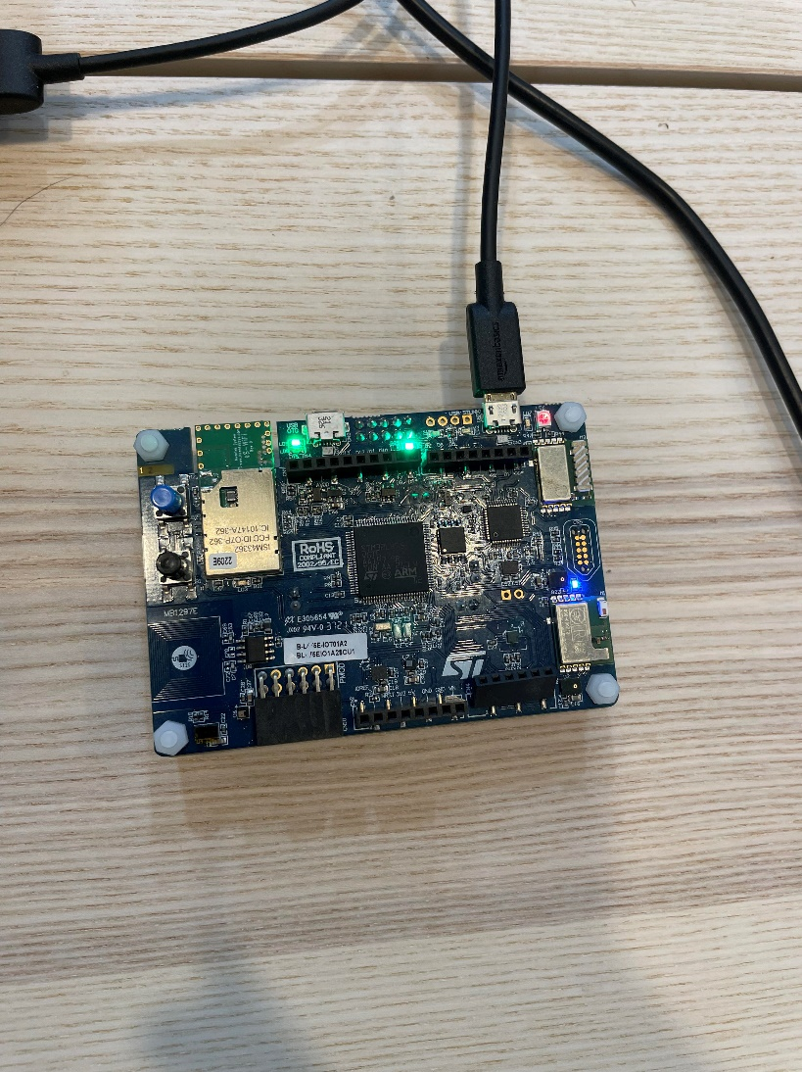

On the picture, you can see green led toggled.

* 1. If you enter char ‘b’ on the terminal.
     1. Print the received character.
     2. And toggle blue LED (if it was ON then will change to OFF). A circuit board with a black wire

        Description automatically generated

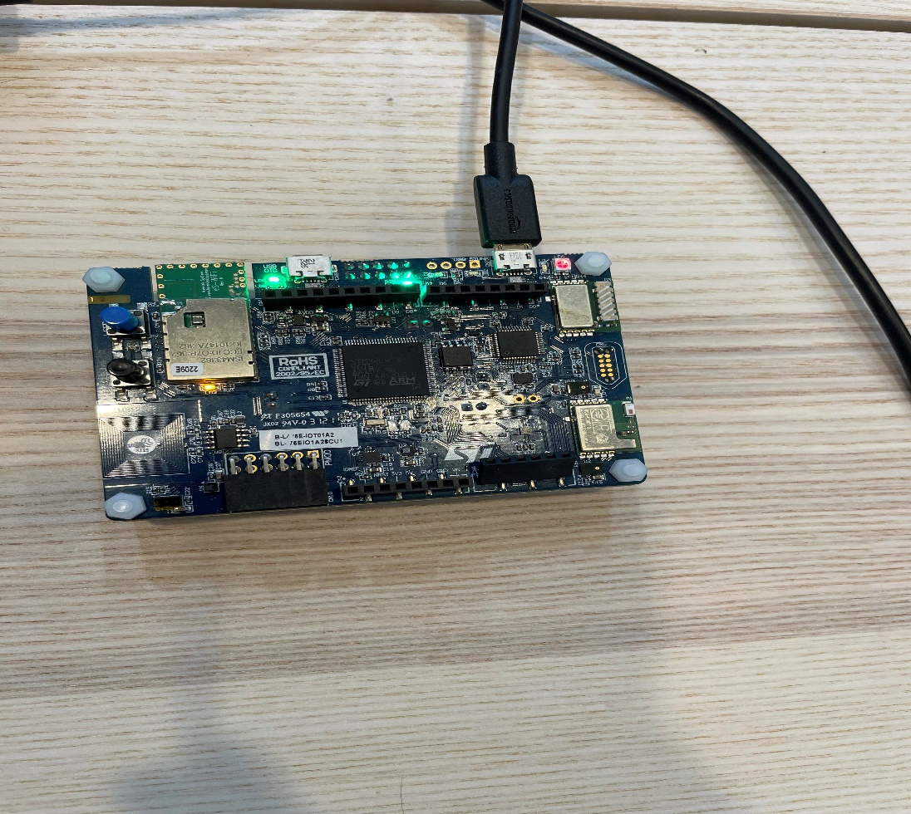

On the picture, you can see blue led toggled.

* 1. For any other character, print “unknown character received”.
  2. Test the software after pressing key b, g and other keys multiple times. Press b or/and g a few times quickly and see what happens. Explain the results compared with Assignment #2 with use of interrupt now.

By using interrupt mode, I do not have to manually set a delay inside the code to wait for the UART to finish transmission or reception, I can simply use a flag to inform that Tx and Rx is complete, so minimum wait time in between. In sum, even if I pressed b/g key very quickly, the program can still respond promptly, not like assignment 2 have some delay.

1. Create mySquareSum.s file. This file will implement a routine which will take integer value and return integer.
   1. For a given integer take the square up to this integer and add it. So, for 3, it would be 3^2 + 2^2+1^2 = 14.
   2. Create another menu with character v, and pass fixed value, say 3.

1. Create a method, numOnes(), in main.c and implement in assembly.
   1. This method takes one integer argument and return number of 1’s.
   2. Create another menu n, pass fixed value, say 7, to this method.

1. Implement the callback method for HAL_GPIO_EXTI_IRQHandler().
   1. Print “Blue button pressed” on serial console if blue button is pressed.

1. Implement enable and disable interrupt using interrupt registers (**No HAL or CMSIS methods**) for a given interrupt.
   1. Add another menu with char “d” to disable the interrupt and “e” to enable interrupt.
   2. Press the blue switch a few times and observe “Blue button pressed” message on the console.
   3. Press d key to disable the blue switch interrupt. Now press the switch and should see no “Blue button pressed” message on console.  But another key should work.
      1. I suggest using blue switch interrupt to disable interrupt to keep displaying the character on serial console.
   4. Now press the e key to enable the blue switch interrupt. Press the switch and should see "Blue button pressed” message on console. This means our enable and disable interrupt method is working.

The test result was successful. When I pressed the d button, the blue button interrupt is not working, but when I press e button, the EXTI interrupt got enabled again, and blue button is working.

1. Implement method myDisableAllIntr() to disable all interrupts
   1. Create another menu with character ‘a’ to invoke myDisableAllIntr().
   2. Press key a and it should disable all interrupts.
   3. Now press any key or the blue switch and notice that nothing is shown on the screen, because all interrupts are disabled.
   4. Reset the board and everything should be back to normal.

The test was successful, before I pressed a button, everything worked well from the requirements 1-5. When I pressed a button, all the interrupts were disabled, so UART, button press all not working. When I reset it, everything works again.